The Impact of Germany’s Economic Conditions on University Enrollment in STEM and Business Programs

by
Andrej Kiselev

A thesis for Econ 4405E
at
the School of Management, Economics, and Mathematics
King's University College at Western University

Abstract
This paper explores how the Economic Performance of German regions impact the number of first-year university enrollments for Stem and Business Programs. Both programs have a big share of university enrollments due to much employment highly related. Most of these employment opportunities require their employees to receive a bachelor's degree. This correlation makes for a necessary paper investigating the relationship between the labor market and rate of enrollment. Educational programs are a factor in the growth of a country's economy due to supplying an important source of labor. Understanding how the labor supply reacts to the current economic performance will help the market prepare efficiently and show the direction of the future.

- Introduction
Post-secondary education is a major factor in a country’s human capital and economic growth. The decision of whether one should pursue higher education is influenced by multiple factors such as their family background, income opportunities, labor market, and economic conditions. Germany has major industries such as the automotive, mechanical engineering, chemical, and financial services (Deutschland.de, n.d.). Changes in economic performance may significantly affect the enrollment in related Stem and Business University programs as they are required for much employment in these industries.
Generally, individuals with higher education experience a lower risk of unemployment and are more likely to have higher income (OECD, 2025). Education is a factor in the growth of a countries production capital. Higher rate of educated labor supply relates to constant efficient economic growth due to the expansion in knowledge and productivity (Becker, 1964). It is a major contributor to technological change and capability which is prevalent in Germany. The top industries in Germany all require educated individuals to grow their production and innovate further. Understanding how their labor supply responds to current economic conditions will help prepare them for changes in the future.
This paper studies whether labour market and economic conditions affect first-year university enrolment in STEM and Finance across German states from 2008 to 2022. Using panel regressions with state fixed effects, I find a clearer and more stable relationship for STEM than for Finance. The evidence found through this study will be relevant to university education development, and labour market preparation.
- Literature Review
Existing research explores how economic conditions impact educational decisions, but less attention has been paid to how labour market factors influence enrolment decisions in STEM and Finance. This paper contributes by comparing how enrolment in these fields responds to labour market conditions in Germany
A relevant study to this topic of research is one by Long, B. T. (2014), analyzing how the Great Recession affected Higher Education. It investigates how the recession impacted college enrollment and the cost to families. The focus is College affordability and its significant impact on individuals applying. Theory suggests that as income decreases and unemployment increases, people are more likely to pursue higher education. To understand how the recession impacted enrollment, the study uses regression analysis to understand the significance of assumed factors. The results were similar to past research and theory showing a positive effect on college enrollment at the start of the recession. It used the complexity of an increase in tuition costs and debts to see if there would be a net negative due to these factors, but the hypothesis was not found to be true.
The study is relevant to this paper as it focuses on the effect of the economic conditions on college enrollment. It used a smaller timeline and focused primarily on the impact of the recession. This paper will focus on a longer time frame to understand if economic conditions have an impact on two industries. Focusing on two industries that are some of the leaders in higher education labor supply will help understand how changes affect economic production growth.
With cost of education being studied in the previous paper, Germany has a relatively low tuition cost and according to Bruckmeier & Wigger (2014), it is not a significant factor in enrollment. The paper investigated whether an introduction of tuition fees in Germany would negatively impact Highschool graduates in wanting to pursue further education. The cost of tuition is relatively low with many students not having to pay due to their financial backgrounds. Therefore, tuition fees are not a significant factor in the decision to enroll in university. Tuition fees are additionally quite stable across all states. My paper uses this study as evidence to not include tuition fees as a variable in the regression analysis.
- Data and Methodology
The data referenced and applied in this study is from the Destatis Databank and Bundesagentur für Arbeit. Both sources are relevant to the analysis as they provide the important variables included in the model. The Destatis Databank is an official Federal Statistics Office. They accumulate all sorts of data related to the country’s economic performance. One can find peer reviewed data sets on information such as family income, labour statistics, employment statistics, and education statistics. This creates a reliable databank for this research, as the datasets are relative and accredited. All variables but Youth Unemployed are sourced from the Destatis Databank. Bundesagentur für Arbeit focuses its research on related subjects such as unemployment. It is an accurate and accredited databank to help individuals understand the labour conditions in Germany.
The timeframe for the data is from 2008 to 2022 capturing multiple economic downturns and enabling an accurate analysis fully capturing economic and labor market changes. This time frame will capture economic events such as the financial crisis in 2008, and the economic inflation in 2020. Focusing on a longer time frame will also help account for economic timeframes that experience market instability to see if it impacts students’ decisions. This will be analyzed through a robustness check.
The data is a panel of 16 states from 2008 to 2022. Each state has its own characteristics with different main industries. Nordrhein-Westfalen has the highest total GDP of all states. Other states such as Berlin have the highest rate of unemployment. These characteristics will improve the model by highlighting what impacts university enrollment. The difference in each data sample allows for an in-depth analysis and is important due to the higher education systems. All universities are funded by their state, meaning that universities around the country will have funds allocated differently as explained in Strehl, Reisinger, and Kalatschan (2007). This can cause differences in programs and the demand of each state. To control funding by states, the paper uses a variable investigating the financial expenditure of both Business and Stem programs.
With a data panel of 16 states over 14 years, there is a total of 240 observations. Some variables have missing values which lower the number of observations. Table 1 highlights each variable and description used in the research.
Table 1: Data Description of Variables
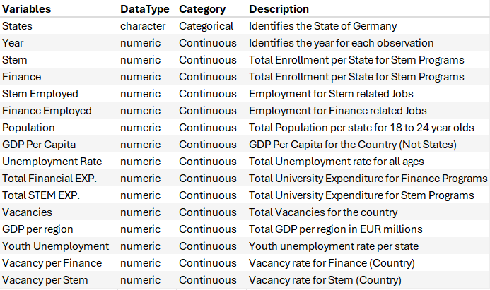
The variables used to measure economic performance in Germany are Youth Unemployment Rate and Gross Domestic Production per Region. These rates are yearly adjusted and by state. The unemployment grows in 2008 to 2010 which is due to the recession, and again in 2019-2021 due to the corona virus pandemic. The states with lowest unemployment rate are Bayern and Badden-Wurttemberg, both located in the south of Germany being a major hub in the industries that the paper investigates. The state with highest unemployment rate is Berlin with a range from 9.1% to 15.2%. Having two timeframes with a higher unemployment rate will show the significance of changes in economic conditions. The GDP per Region represents the gross domestic product in each state. It is an important variable that controls production growth in each region, which will help control for states economy. This makes for a better factor than GDP per capita
Other important variables being used in the analysis include employment for both industries. This controls changes in employment, which may be due to factors such as demand, economic conditions, or lack of opportunities. Jobs included in the STEM industries are manufacturing, construction, information and communication, professional scientific and technical activities. These are all industries that are relevant to individuals studying the programs collected. The variable named “Finance Employed” include jobs in Financial, Insurance, Business, Real Estate, and Business Services. All industries are ones that individuals studying both programs can enter after graduation. In the data, there are more Stem employed individuals, but this could also be due to more jobs in those industries that are not related to Stem, such as physical labor, human resources, etc. The finance related employment variable has more jobs that require a financial related university diploma.
The last two control variables are “Population” and Vacancies. Population is per state targeting an age group of 18 to 24 representing a higher percentage of the group enrolling in university programs. Vacancies indicate unoccupied positions showing a need for labor supply in those industries. The variable “Vacancies” is not industry specific which is why the data set consists of two vacancies, “Vacancies per Stem” and “Vacancies per Finance”, indicating each industry. The variables represent country level only due to state information being less available. This will not interfere with the results, as students are able to work in any region of Germany after studies. The Vacancy Rate for Stem has data available only from 2011. It indicates demand for labor and is an indicator showing rise or decline in opportunities.
There are 2 dependent variables as both industries will be analyzed separately. These are the Business and STEM Enrollment variables, “Stem” and “Finance”. Included in the business program are the courses, Business Administration, Business and Economics. All states had data for the programs and are in the most demand compared to other finance related programs. The courses covered in Stem enrollment are Civil Engineering, Computer Science, Mechanical Engineering, Mathematics, and Physics. These are all Stem related programs that are relevant in the industries used in this analysis. To indicate first-year applicant effects, the data is only for first year enrollments. The analysis will show how the independent variables positively/negatively impact the enrollment and whether they are a significant factor in the decision behind it.
This paper focuses on quantitative analysis. It analyses the relationship between university enrollment and economic labor indicators through a Panel Data Regression. The main explanatory variables are lagged youth unemployment and vacancy rates, with GDP per capita and higher-education spending per student included as controls. One year lag highlights that decisions are made on data from previous year. This means that the Stem Enrollment model will start from the year 2012, due to the vacancy rate only being available from 2011. The Finance model will be from the year 2009 to 2022, as data is available in all years for each variable.
- Econometric Model Background
Now that all the variables have been described, it is important to create an efficient model. The paper analyzes separate models to show both dependent variables. Some of the variables will be transformed to eliminate collinearity and help with the scales.
Model 1:
Stem Enrollment ​=β0​+β1(​YU,t−1​) + β2​(VS,t−1)​+β3(​log(GDP,t−1​))+β4(​EXPS,t)​+ϵ,t​
Model 2:
Finance Enrollment ​=β0​+β1(​YU,t−1​) + β2​(VF,t−1)​+β3(​log(GDP,t−1​))+β4(​EXPF,t)​+ϵ,t​
“Stem Enrollment” and “Finance Enrollment” are both dependent variables representing each program. They describe the rate of enrollment for the population size aged 18-24. “YU” represents the Youth Unemployment. This variable is lagged by one year indicating that the dependent variable will be impacted by Youth Unemployment from the previous year. “VS” represents the vacancy for Stem related jobs highlighting job opportunities in Stem. “VF” is similar to “VS”, but it represents the vacancy for Finance related jobs instead. These variables highlight the labor market in these specific industries. “GDP” captures the Gross Domestic Production per state highlighting economic performance. “GDP” is logged and lagged such as “VS” and “VF”. “EXPS” and “EXPF” are both variables demonstrating the educational spending on each type of program to control for university spending. This is the only variable that is not lagged.
Since the models are a Panel Data regression, the specification includes year fixed effects to control for time shocks. In addition, standard errors are clustered at the state level. This will help with heteroskedasticity and account for any correlation. These are important for accurate regression results.
To explain the modelling process, the collinearity between the variables will be inspected first, which is found in table 2. Table 2 highlights the correlation between each variable. Red represents positive correlation, and blue is a negative correlation. More Contrast indicates higher correlation. The model will be unreliable due to inflated standard error and coefficients being mixed if correlations are highly significant.
Table 2: Correlation Matrix of all Variables with data available from 2008 to 2011
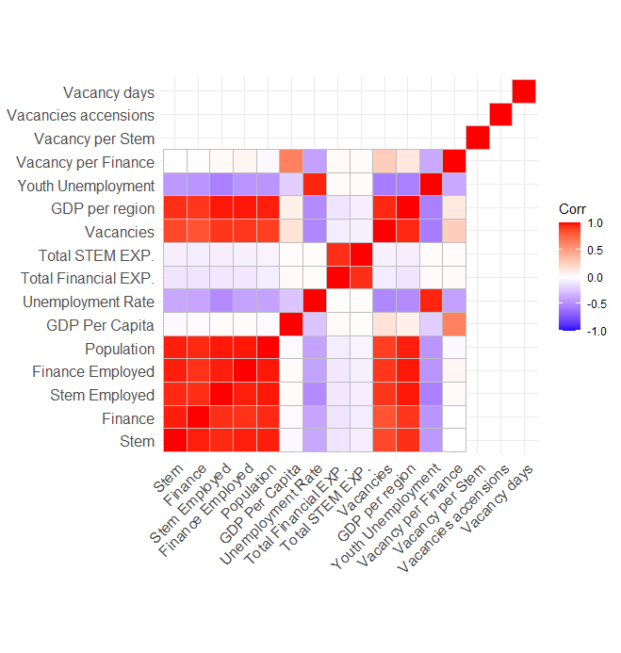
The table shows a lot of variables do have higher correlation. Both employment variables for each industry are highly correlated with the GDP per Region variable. The GDP per region variable is a better fit economic indicator of the labor market for this analysis, as the employment variables include jobs that do not require the related university programs. Therefore, they are not the most appropriate representation of what students will base their decisions on. The GDP per region variable is an indicator of the state’s economy, which is a more significant indicator.
Vacancy per Stem is not showing any correlation due to having some years with unavailable data. Vacancy per Finance has little correlation to both dependent variables. The simple Vacancy variable does have more correlation, but it is high correlated to GDP per Region. This high correlation may cause issues in reliability; therefore the industry-specific variables will be better indicators representing whether industry vacancy is a factor in the decision.
Both program expenditure variables have a negative correlation to the independent variables. One would expect that the more a university program is funded, more students will be interested to enroll. Because both variables are highly correlated, I estimate them in separate models to help interpretation.
An important relationship is that of the population and enrollment variables. This high correlation will cause issues if it is included in the model. Currently it represents that a higher younger population results in more enrollment. This is an expected relationship, but it will be eliminated by the transformation of both variables. Both enrollment variables will be divided by the population variable. This will create the dependent as a percentage of the youth population enrolling in Stem and Finance programs. The new dependent variable will be logged to eliminate high variance and reduce skewness. This transformation allows the independent coefficients to interpreted as percentage changes to the enrollment rates. This is a better representation as each state has a different population size. I include a visualizing of this description of both dependent variables below.
Stem Enrollment: ln (STEM/Population aged 18–24)
Finance Enrollment: ln (Finance/Population aged 18–24)
Another variable that is logarithmic is the independent variable “GDP per Region”. Due to the large scales of each value, taking the log of it will help reduce skewness and high variance. It will also be a better representation of the GDP as each state is of different economic size.
As explained earlier in the model, most variables are lagged. This means that it will be using the value from the previous year. As most of these variables are not publicly available until the end of the year, using the lag of these variables will help with the accuracy of the model. It creates a more realistic and appropriate representation of the relationships impacting enrollment.
- Results
The Econometric model has now been developed, but it needs to be analyzed and applied to the data set to test it. Testing the econometric model will allow us to understand which variables are significant in the decision to enroll in either Finance or Stem related programs. It will also indicate whether they positively or negatively impact it.
Table 3: Fixed-effects regression for STEM enrolment
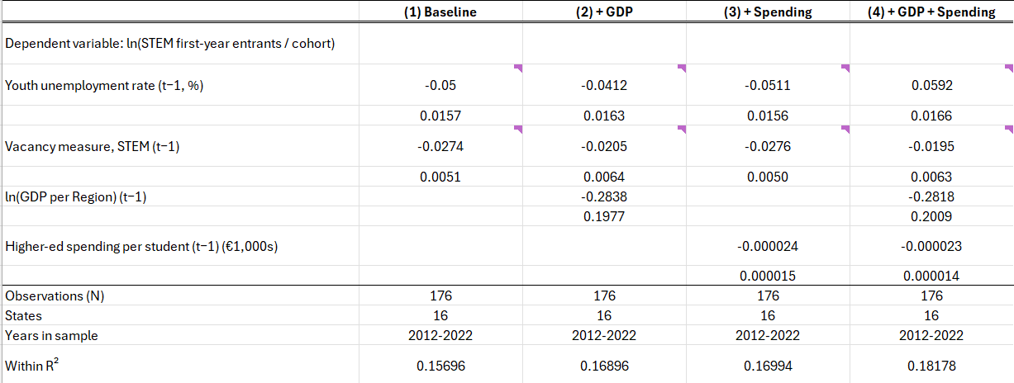
*Significance is indicated by Purple Tag in corner of each value
* Standard Errors below coefficient values
Table 3 represents regression estimates investigating the relationship between labour/economic market indicators and STEM first-year enrollment rate. In the first column, a base regression is performed to represent the two most significant variables with no control variables. Youth Unemployment rate is a significant variable with an estimated negative 0.05 coefficient. This indicates that a percent increase in youth unemployment is related to a decrease in related Stem program enrollment rates. A negative relationship between Youth Unemployment and enrollment indicates that when youth experience an increase in unemployment, they are less likely to enroll in STEM university programs. This is an interesting outcome as past literature such as the paper by Long (2014) indicated opposite outcomes. Their analysis resulted in a positive relationship, indicating that a rise in unemployment related to more students enrolling in university.
The lagged Stem vacancy rate is also indicating a negative significant relationship. An increase in vacancy rate indicated a negative impact on the enrollment rate in Stem programs. This is an interesting relationship as one would expect more job opportunities to have a positive impact on first-years wanting to enroll. Such relationship could be due to students wanting to see a market where jobs are fulfilled rather than open. They may believe that a lower vacancy rate indicates a higher chance of market hiring.
Both Youth Unemployment rate and Stem Vacancy rate are both negative and statistically significant measures across all four specifications. Column 2 and 3 in the table introduce new variables, and column 4 is a full model specification with all important indicators.
The log of lagged GDP per region is introduced in Column 2. With the introduction of this new variable, there is no significant change to the others in the model. GDP per region has a negative relationship with the enrollment rate but is not of any significant. There is a minor increase in the R-squared.
Column 3 introduces the Expenditure Variable for Stem programs. The coefficient is rather small due to scale of the values. The regression indicates a negative relationship. This is an interesting outcome as one would expect more spending to have a positive outcome on students wanting to join the program. Since it is not significant, it may just not have enough input to recognize it otherwise.
The final model includes all variables. The time frame for the model is from 2012 to 2022. This is a 10-year time frame allowing for multiple economic changes to showcase a long-term indication of the relationships. The statistically significant variables remain to be Youth Unemployment rate and Stem Vacancy rate. All variables in the model have a negative relationship with the Stem enrollment rate. From the two significant variables, we can interpret that students enrolling in Stem programs are looking for a market with less youth unemployment and less unfulfilled job listings. Stem majors are interested in a positive labor market that is hiring available applicants at every opportunity.
Table 4: Fixed-effects regression for Finance-related enrolment
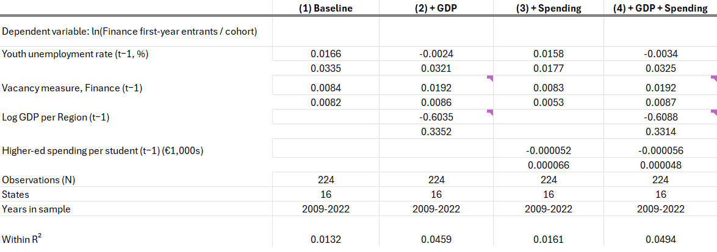
*Significance is indicated by Purple Tag in corner of each value
* Standard Errors below coefficient values
Table 4 regression results of 4 specifications analyzing the relationships between the labor/economic market indicators and Finance related Enrollment rate. There are 4 specifications with a base model such as table 3. The difference in variables for this model is that both Vacancy and Expenditure are finance industry measures.
In the base model, Youth Unemployment and Vacancy measures have a positive and statistically insignificant relationship with the Finance enrollment rate. This indicates that an increase in Unemployment and Vacancy impact the enrollment rate positively. More students are to enroll in finance related programs if these variables increase.
The second specification introduces the log of one-year lag of GDP per region. The introduction of these variable changes the model. For example, Youth unemployment has a negative coefficient indicating a negative relationship. This is like the Stem model suggesting that a rise in unemployment makes less people want to enroll in finance programs. The introduction of GDP makes Vacancy and GDP per region have statistical significance. Vacancy rate remains as a positive relationship demonstrating that Finance students see available job listings as positive indicator. The coefficient estimate is less small, but still significant. The log of lagged GDP per Region has a negative relationship. This estimate is more impacting than that of Vacancy indicating that Finance majors are influenced by the gross production in their state. A rise in gross production causes less people to want to enroll in the program. While they do have some negative correlation in the correlation matrix, it is not of significance in this model. This could be due to youth unemployment having a relative high p-value. This will be further inspected in the robustness checks.
Specification 3 introduces the Expenditure on Financial programs at universities per state. The variable has a negative relationship with enrollment rate. This result is like that of the Stem programs. This simply suggests that students are not reactive to education spending when including other economic factors. These other factors are of higher impact than University spending, which is recognized by the minor increase in R-squared.
The final model includes all variables. All positive/negative relationships remain stable compared to specification 2. Expenditure on Finance programs remains as a negative relationship. This model further proves that Youth unemployment is highly impacted by the introduction of GDP per region. The timeframe of this model is from 2009 to 2022. This slightly bigger time period includes the economic downturn during the 2008 economic crisis.
To test the final models, a robustness check is performed to evaluate if the models remain stable. The first robustness check is an elimination of the covid period (2020-2022). This is captured by both models and may have a significant impact on the results of each estimate. A second robustness check evaluates whether the estimates remain stable if the variables are lagged by 2 years instead of one.
Table 5: Robustness checks of Both Models
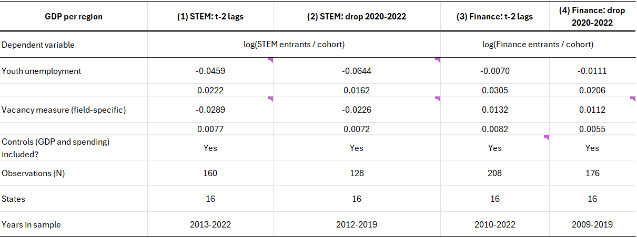
Table 5 highlights the new results for Youth Unemployment and Vacancy measures. The other variables were also conducted but not shown in the table.
The STEM model is stable and not sensitive to the new specifications. The relationships remain similar with the same coefficient relationships (negative) and significances. From these checks, we can recognize that First-year students do rely their decision on whether they should enroll in Stem programs by labor market conditions. This is proven by both variables remaining with significance after the robustness checks.
The Finance program model has different results in comparison. Both variables have unchanged relationships (positive/negative), but their significance does not remain stable. This indicates that significance is dependent on the time periods. The Vacancy rate remains significant once Covid is dropped. This indicates that the students remain to use a one-year lag of job availability as an indicator. But, when the model uses a two-year lag of variables, only GDP per Region is significant. While the model passes the robustness checks, the estimates in the final model must be taken with caution.
- Conclusion
Education is an important foundation of society that contributes to the growth and development. Countries such as Germany believe that education is a factor in the growth of production and wealth. This is recognised through the low costs and easy access to post-secondary education.
I performed a Panel Data regression to control for States and Years allowing an in-depth analysis of the model. With the production of two separate models, we can see the differences in how Stem and Finance applicants react to the variables.
Students in enrolling in Stem-related programs use labor market indicators to help in making their decision. The one-year lag of Youth unemployment rate and Stem Vacancy rate are both significant measures in the model. Both variables have a negative relationship to the Stem-enrollment rate. This suggests that the applicants desire a labor market that is actively hiring graduates.
While the Stem model is quite stable, the finance model is less robust indicating an interpretation of caution. They are reliable interpretation of how Finance first-year applicants may decide to enroll, but caution is suggested. According to the final model, the finance-related Vacancy rate and GDP per Region are both significant variables in the decision to enroll. Vacancy rate has a positive relationship, suggesting that job availability is an important factor. The GDP per region has a negative relationship indicating that individuals are more likely to apply to Finance programs when the German gross domestic production is decreasing
This paper finds that labor market conditions, particularly youth unemployment, are associated with higher STEM enrolment. The results for Finance are less robust, but they suggest a role for vacancies. Limitations include the reliance on national vacancy measures.

References
Becker, G. S. (1964). Human capital: A theoretical and empirical analysis, with special reference to education. National Bureau of Economic Research.
Bruckmeier, K., & Wigger, B. U. (2014). The effects of tuition fees on transition from high school to university in Germany. Economics of Education Review, 41, 14–23. https://doi.org/10.1016/j.econedurev.2014.03.009
Deutschland.de. (n.d.). Germany’s industry: The most important facts and figures. https://www.deutschland.de/en/topic/business/germanys-industry-the-most-important-facts-and-figures
Long, B. T. (2014). The financial crisis and college enrollment. In How the financial crisis and great recession affected higher education (pp. 209–234). University of Chicago Press. https://doi.org/10.7208/chicago/9780226201979.003.0007
Organisation for Economic Co-operation and Development. (2007). Funding systems and their effects on higher education systems (OECD Education Working Papers No. 6). https://doi.org/10.1787/220244801417
Organisation for Economic Co-operation and Development. (2025). Education at a glance 2025: Germany. https://www.oecd.org/en/publications/education-at-a-glance-2025_1a3543e2-en/germany_fa91d155-en.html
Sudarwati, N., & Naim, S. (2022). The urgency of education in economic development and human resources: A theoretical perspective. Tadbir: Jurnal Studi Manajemen Pendidikan, 6(2), 169–186. https://doi.org/10.29240/jsmp.v6i2.4667

